Galena Country Estates 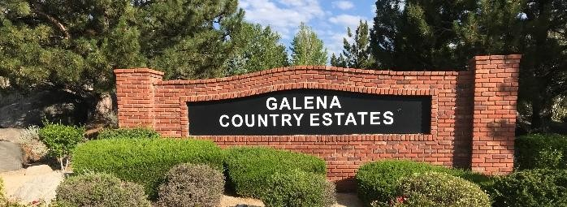Fall News 2026 Compiled by Cynthia Reed
Green Waste Dumpster Success
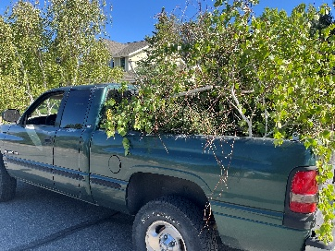
Over Memorial Day weekend, our Firewise Team scheduled five 30 cubic yard Green Waste Dumpsters to be placed in our neighborhood via two different grant opportunities managed by Reno Fire PD and Living with Fire, UNR. Our homeowners filled them up in less than three days and the team still had to take another 40 bags and 12 cubic yards to the dump via trailer.
Thank you, homeowners!
You can order green waste dumpsters for d$525 through Waste Management by e-mailing Anthony Grapton directly: agayton@wm.com Five homes could go together and have it for a week for $105 each!
If you want to be on the next surprise Green Waste Dumpster list, please e-mail Cynthia Reed at
GCE.Firewise@gmail.com. We may be able to get more in the fall and definitely next spring.
Fall Community Clean-up
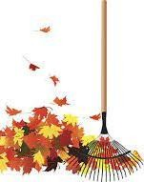
“Northern Nevada’s firefighters, land managers, and wildfire experts are working towards the prevention of catastrophic fire events. One factor is making this goal nearly impossible—Private properties with poor defensible space,” says Casey Knapp, Fire Adapted Ambassador for FA431.
Our homes are over 30 years old and many yards were over-planted. Homeowners have several ways to dispose of green waste:
First, Truckee Meadows Fire PD (TMFPD) will hold a Green Waste Collection in October in Washoe Valley at the Nevada Division of Forestry Fire Station, 885 Eastlake Blvd, from 9 am. to 4 pm. Check tmfpd.us for dates and site details.
Second, Waste Management will collect up to
6 extra bags/trash cans (leaves, limbs, pine needles & other trash) with NO stickers required during regular trash pickup for four weeks in November.
Third, homeowners have FOUR FREE dumps at the WM transfer station off Sutro. Just bring a WM bill with account no. and ID. Three cubic yards per load.
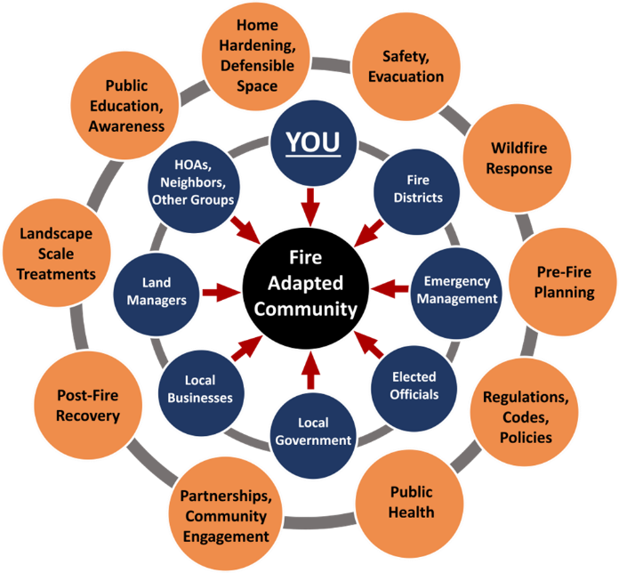

“Do something,” says Bill Steward, owner of Foresight Fire Consulting and the Wildland Fire Coordinator at TMCC. “It doesn’t have to be a major project. Any amount of effort helps. When we all work on approachable tasks, we make an impact in our community.” Take his “Wildfire Preparedness for Homeowners” class through TMCC’s Educational Programs Inspiring the Community (epic.tmcc.edu) on October 3, 2026, 9 am.-1 pm. at Meadowwood Center. $69

E-bike & Bicycle Safety
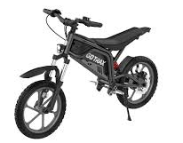
Thank you to parents who are
reviewing traffic

rules and general manners with their children. Issues have improved but we have homeowners reporting some close calls. Girls on scooters almost hitting truck head-on because they were talking and looking at each other instead of noticing a vehicle moving toward them OR the stunt riders down Stowe and Solitude Drives giving the finger to homeowners who ask them to stop OR the boys blocking the FedEx driver in a delivery truck with their bikes. So, keep those safety talks on the front of everyone’s minds. Thanks for wearing helmets!

Traffic Speed Limit 25 MPH
in Neighborhood
Do you want a child killed or an adult crippled? Please slow down! Drivers are so used to speeding, nearly a third of them are convinced that “no one actually drives the speed limit,” according to new research from the AAA Foundation for Traffic Safety. The study, released April 18, found that speeding has become “so common that many drivers consider going 10 mph over the posted speed limit acceptable.” 25 MPH PLEASE !

Fire Hydrant Reminder: Homeowners need to clear a 3-foot radius around the hydrant; removing snow, bushes and limbs, so firefighters can access hydrants fast.
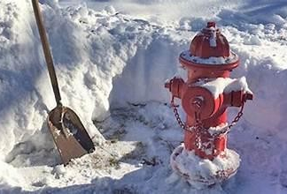
Hydrants are marked with a reflective orange pole to locate
them at night and during snowstorms. Do not remove the poles.

Want the bears to hibernate?
Last winter the bears were still around in December because they could find fruit, garbage and bird food to eat in our neighborhood. Department of Wildlife recommends picking the fruit up off the ground and off trees to keep bears away. Get bear proof trash cans (grant incentive from City of Reno) or ordering special pins you can install on trash bins and put bird food and feeders in garage at night.
Make loud sounds if bear nearby.
Several homeowners have had fences torn down and bears are hanging out seemingly fearless in ditches. A homeowner suggestion: spray trash cans with ammonia to keep bears away.
Junk Your Juniperss
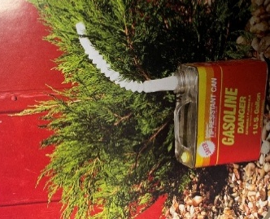
Junk Your Junipers
The “Little Green Gas Cans” are going to be removed from our Common Area entrances… about 10. We need to show Truckee Meadow Fire PD that our HOA is following their guidance after performing a Community Wildfire Risk Assessment (2026). Pick up a Living with Fire Handout at the Little Free Library on Solitude Drive.

Why?
Junipers collect dead leaves and trash.
Junipers and trapped debris burn hot and fast.
Junipers give off large flames and generate abundant embers. (WildfirePartners.org)
In the Caughlin Fire After-Action Analysis, junipers located next to structures were identified as one of the contributing factors to the loss and damage of homes. (LivingWithFire.com)


In March 2026, TMFPD filed for a grant through the Nevada Fire Chiefs Grant on our behalf to reduce the Wildland Urban Interface (WUI) fuels on the westside of our subdivision by creating a 30-foot fuel break between Galena Country Estates (GCE) and the Reserve at Monte Rosa. This high hazard area is covered with sagebrush, bitterbrush and rabbitbrush which would be chipped back on-site.
The second part of the grant would create a 15-foot firebreak along homeowners’ fence lines all along GCE South Common Area along Mt. Rose Hwy. Remove all brush beneath the pine trees after limbing up all trees to 6’ from the ground or 1/3 height of tree. Reduce all wildland brush by 50%. It’s about 5 acres total but rough terrain.
TMFPD was not awarded the grant so we are going to try again next spring because firefighters have the right equipment to do the job. But we need to show TMFPD that homeowners are doing their part to reduce fire fuels within the subdivision.
- Our landscaping company cut down wildland brush within 6-feet of homeowners’ fence lines between Telluride Drive and Sundance Drive.
- The Board will pay to remove junipers in both Common Area Entrances, too.
But we need homeowners to do their part:
- Limbing up trees so branches are not draping over wooden fences especially those bordering Mt. Rose Hwy. High winds come from the south creating high fire hazard.
- Remove junipers and other gasoline plants within 30’ of your house.
- Clean out ditches on your property. Clear combustible materials, like leaves and pine needles, from ditches and along fence lines. Hardening your House” means making it hard for embers to ignite your property.
Choosing the Right Plants for the Northern Nevada’s High Fire Hazard Areas is a publication on LivingwithFire.org. Chapter 3 has a list of plants to avoid planting within 30 feet of a house such as Arborvitae, Broom, & more.
If you don’t know what a plant is, download a plant identification app, like Seek, or take a small clipping down to your local nursery.
**********************************************
TownSQ
Associa Sierra North moved to TownSq for all email and notification needs. Please register on the TownSq website and/or the app.
Registering not only ensures you stay updated on all community news and meetings and you can also respond to maintenance issues quickly. It also helps in reducing mailing cost ($3+ per letter), keeping our HOA dues low.
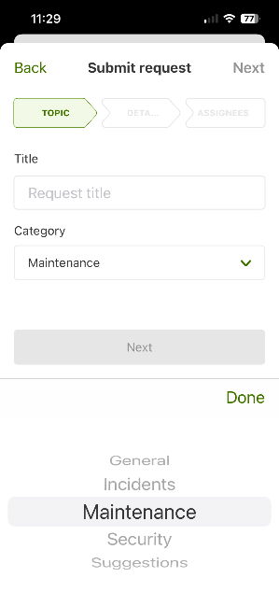
Steps to make a response:
Log into TownSq home page.
Click on Requests.
- Click on green “+”
- Type in Request Title
- Select Category.
  - General
  - Incidents
  - Maintenance
  - Security
  - Suggestions
- Hit Next & add Description and Attachments
- Hit Next & click on Submit

