Galena Country Estates
Spring News 2026
Compiled for free by Cynthia Reed

Homeowners are encouraged to attend HOA/Associa meetings at Raley’s Gathering Room A at 6 pm every two months. Dates are posted on the GCE website (galenacountryestates.com). Our website is for all to learn more about Galena Country Estates. The website is maintained by the HOA Board, not Associa, our management company. If you are a landlord, please make sure tenants are aware of our website to become informed about the neighborhood EVENTS & FIREWISE information.

Architecture Request Form
To file a request, the easy way is to go to galenacountryestates.com and click on form under Architecture. Associa can also send you a pdf link to print. When do you need to file a request?
- Adding a structure in front or back
- New windows or garage doors
- Repainting, even if color is the same
- Changing landscaping from grass to rock or vice versa
- Driveway replacement with concrete or pavers
- Fence replacement
- Not sure, fill out a request.
Whites Creek Spring Flow
Citizens should contact Washoe311 at 775-328-2003 or washoe311@washoecounty.gov regarding issues with the flow of Whites Creek so Washoe County can ensure that proper staff members are notified to address the issue.

Community Garage Sale, Saturday
May 16th

8 am-1 pm.
Signs will be posted at entrances on Telluride and Sundance. General announcements will be posted on Craigslist and Nextdoor but post your own with more details such as address, etc. GCE sponsors ONE community garage sale a year.

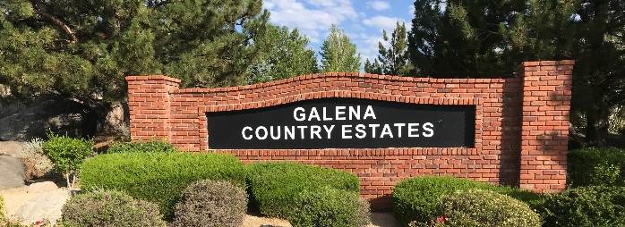
TownSQ

Last year, Associa Sierra North moved to TownSq for all email and notification. If you have not done so already, please register on the TownSq www.townsq.io and/or the phone app. The Board would like to conduct surveys to get your opinions efficiently. Registering not only ensures you stay updated on all community news and meetings, but it will also help eliminate mailing cost ($3+ per letter) in the future, keeping our HOA dues low.

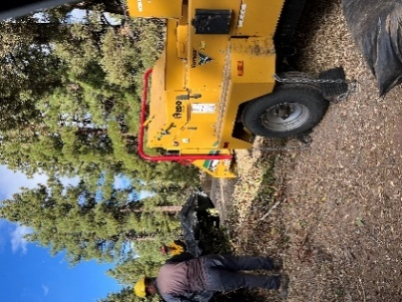
Check out TMFPD Spring 2026 Green Waste schedule. Usually, they collect from 8 am- 4 pm. near Washoe Lake and various locations on weekends in March.


Otherwise,
Waste Management will pick up six bags per home for 4 weeks in May/Nov. No stickers required those months for excess waste collection. All other times, use the excess waste stickers. Or drop off EXCESS WASTE at the Sage Street Transfer Station. 1390 E. Commercial Row free up to four times a year. Bring your statement with account number and ID.
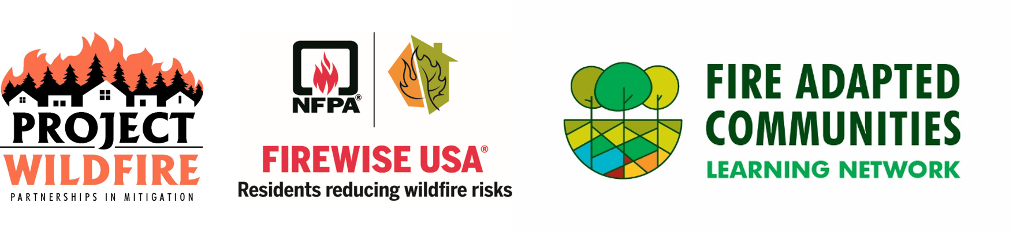
Galena Country Estates has been a Firewise USA member for five years, required by Truckee Meadow Fire PD to receive grants to reduce wildfire risk. For instance, NDF fire crews, cleaned four ditches on homeowner property two years ago. To be a member, our Firewise Coordinator needs data on how many hours our homeowners spend in 2026 creating defensible space by raking up leaves, trimming shrubs and trees, removing brush, junipers, etc. Just estimate hours worked and send info anytime to GCE.Firewise@gmail.com, including cost of renting equipment or hiring professionals to do the work.
Homeowner To-Do List:
- Attend Wildfire Homeowner Education Event on Thursday, April 30th, 6 pm. South Valleys Library. (This is organized by your GCE Firewise Committee and Fire Ambassadors from Galena Forest and Monte Rosa. Flyer posted on TownSq.
- Cut off bottom 1/3 pine tree branches so you can rake up debris underneath the tree. (12’ tree, take off limbs 4’ from ground. Remove “ladder” fuels which can ignite from embers blowing in.)
- Remove excess pine needles, leaves, pine cones, dead branches, and other debris on the property.
- Clear all debris out of gutters. Cut plants and tree limbs away from fencing, roof, and out of drainage ditches on your property. All ditches are on private property so it’s homeowners’ responsibility to clear all grasses, plants, and dead limbs.
- Fences are a “candle wick” for fire. If limbs are touching the fence, cut limbs off so it is clear at least 4’ above the top of the fence.
- Place 1/16” or 1/8” stainless steel mesh over outside vents at the base of your house and under the eaves to block embers from entering.
- Start removing junipers near the house or fencing. Junipers are nature’s “little green gas cans” and will explode into flames.

For more ideas on how to create defensible space around your house, go to our website http://galenacountryestates.com under
Fire Protection or

explore podcasts, including new insurance laws, at
Living with Fire: https://www.livingwithfire.org/podcast

Firewise USA promotes neighbors helping neighbors. Can you help neighbors cut branches? Can you help transport green waste to collection areas? If we can get free green waste dumpsters, will you help? Email Cynthia at GCE.Firewise@gmail.com.

If you have USAA home insurance, you may have a discount off your rate because of GCE involvement in Firewise USA.
***********************************************

Neighborhood Watch Program Meeting
Please attend HOA Annual meeting on March 16 at 6 pm. to sign up for first meeting and discuss possible dates and place for sheriff presentation or contact Larry Crapo, lcrapo@sbcglobal.net.
***********************************************
Water those trees when temp is above 40 degrees. It’s been dry.

At least four homeowners are attending the FAN Summit on Feb. 23-24 at
UNR.

