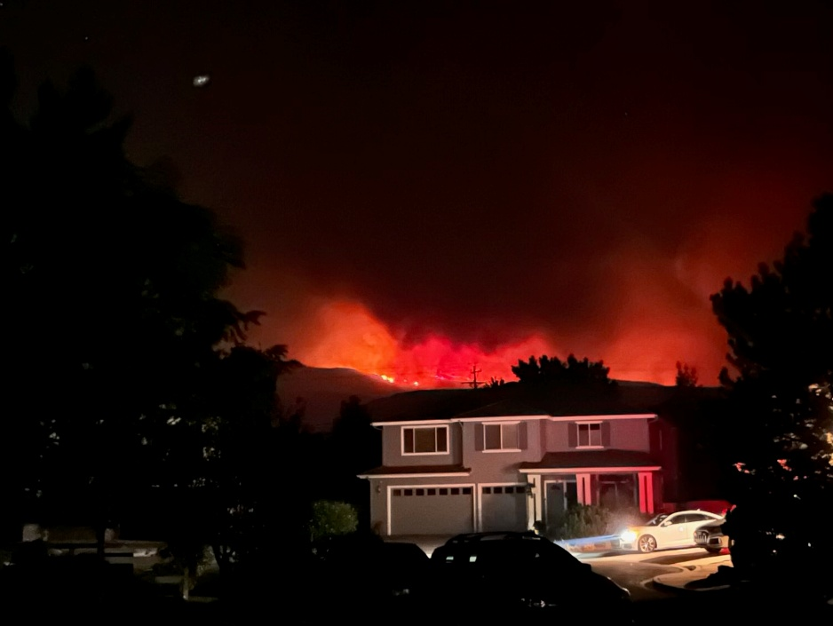**Hi Neighbors,** TMFPD Brett Taylor presented another excellent talk on “Lessons Learned from the Davis Fire on Monday, April 28th, at Raley’s Gathering Room. Representatives from Living with Fire (UNR Cooperative Extension) and Washoe Emergency Preparedness also presented plus distributed pamphlets with more information. Forty homeowners from various subdivisions attended this event organized by your Firewise USA Committee.

Davis Fire from Solitude Drive 9.2025

* Sign-up for new **Smart911** app today. Code Red is being eliminated by September.
* Type in **readywashoe.com** to find out more about evacuation preparedness.
* If you need electricity for medical equipment, contact **nvenergy.com/greencross.**
* Use **perimetermap.com** the most current info from the fire lines. **Watch Duty** is another web app which posts information from several sources. Be aware that social media may be wrong which caused those impacted by Davis Fire to return too soon.
* Follow **police and firefighters’** directions. If you are told to evacuate, **leave**. There are not enough resources to save you. **Respect** NDOT orange-vested employees directing traffic. Watch the **weather forecasts**.
* Take action early. Start packing **To-GO bags** for an evacuation now. Use the attached wildfire evacuation checklist for guidance. Tell relatives where you are going. Plan.
* If the power is out, invest in a **battery** to operate the garage door opener.
* **Power will be turned off** to protect 1st responders and prevent secondary fires.
* Plans for **school evacuations** are not public info. Follow their directions. **Kids are safer at a fire-hardened school than out on the roads in a bus.**
* Create defensible space around your house. Start removing the junipers, “nature’s little gas cans.” Then, look at the bushes and trees which are too close to the house. Put 1/8” stainless steel fire-mesh over vents to keep out embers. Many of us had soot on our driveways. Embers cause secondary fires especially under the house. **How are your actions or lack of action going to impact others in the neighborhood?**
* **Get to know your neighbors.** Work on your Personal Preparedness Plan.
* Do not bake meals or goodies for firefighters. Donate money to purchase items needed.
* Sign up for [www.nvroads.com/my511](http://www.nvroads.com/my511) for road conditions.

**You can e-mail Brett Taylor at** [**btaylor@TMFPD.us**](mailto:btaylor@TMFPD.us) **to get a free defensible space evaluation to help your neighborhood survive the unexpected.**

Your Firewise USA Committee & neighbors,

**Cynthia Reed, Judy Baatrup, Kate Whitfield, and Aaron Ghysels**