**Galena Country Estates**

**Spring News 2025**

Compiled for free by Cynthia Reed

Homeowners are encouraged to attend HOA/Associa meetings at Raley’s Gathering Room A at 6 pm every two months. Dates are posted on the GCE website (galenacountryestates.com). Our website is for all to learn more about Galena Country Estates **including tenants**. If you are a landlord, please make sure tenants are aware of our website to become informed about the neighborhood EVENTS & FIREWISE INFO.

**Community Garage Sale, Saturday**

May 17th

8 am-1 pm.

Last year, several homeowners participated in the spring garage sale. Signs will be posted at entrances on Telluride and Sundance. General announcements will be posted on Craigslist and Nextdoor but post your own with more details such as address, etc. GCE sponsors ONE community garage sale a year.

**Whites Creek Spring Flow**

**It is best that citizens contact Washoe311 at 775-328-2003 or**[**washoe311@washoecounty.gov**](mailto:washoe311@washoecounty.gov)**regarding issues with the flow of Whites Creek so Washoe County can ensure that proper staff members are notified to address the issue.**

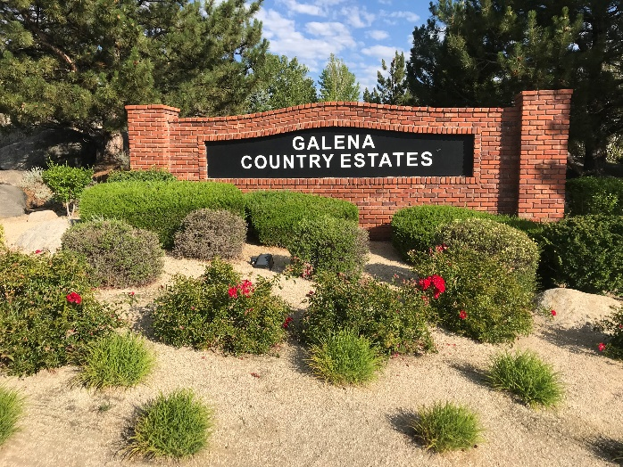

**Starting January 1, 2025** Associa Sierra North is moving to TownSq for **all** email and notification needs. **We need about 90 homeowners to register on the TownSq** [**website**](http://www.townsq.io/)**and/or the app.** The Board would like to do surveys to get your opinions easily. Registering not only ensures you stay updated on all community news and meetings, but it will also help in **reducing mailing cost ($3 per letter)** in the future, keeping our HOA dues low.

Register with TownSq

(Homeowners only)

[www.TownSq.io](http://www.townsq.io/) is an interactive **secured** platform intended for efficient communications with the Association and to see your real time account information for assessments, payments, documents (minutes, financials), forms and more.  [www.TownSq.io](http://www.townsq.io/) is available for Android and iOS…**Download the App and have account information accessible on your phone or log-in on your computer!**On TownSq, you can see Association information and your account information real time, you can make payments online and you can view Association documents and announcements, including meeting agendas. TO VIEW DOCUMENTS: Select “Documents” located on the left-hand column, Filters, Category, and then select the category type you would like to see (Announcements, Financials, Forms, Governing Documents, Insurance, Minutes), and click Apply.  Note that “Internet Explorer” does not support TownSq (a different browser should be selected). And, for phones and ipads, be sure to download the google app.  
  
BELOW ARE THE INSTRUCTIONS TO REGISTER FOR TOWNSQ. Please go to <https://app.townsq.io/login> and follow the steps below to register your account:  
  
1. If you are not on the “login” page, you may need to select “Help & Support” and then Homeowner Login”  
  
2. Click "Sign in with Account Number"  
  
3. Enter your account number and property ZIP code (ENTER ZIPCODE OF ASSOCIATION HERE), first & last name.  
  
4. Click "Continue."  
5. Click on Sign up.  
6. Once registered you can modify your ‘profile’ for how you want to receive notices (or not) from the HOA. **If you need further assistance, please contact TownSq Customer Service at 844-281-1728, or the Associa office at 775-626-7333.**  
  
Please note, the contact information you enter through TownSq is not linked to the HOA data base. Contact the Associa office directly with any changes or updates to your email, phone and/or mailing address plus any tenant information.

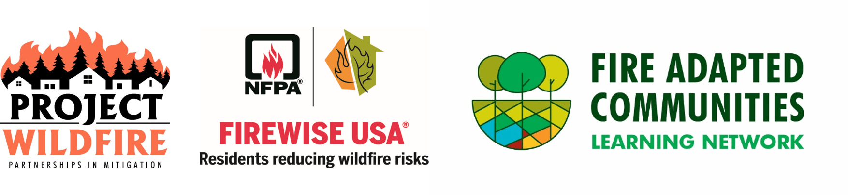**Fire Adapted Nevada Summit**

**March 17 & 18, 2025**

Mark your calendars for the 2025 Fire Adapted Nevada Summit on March 17th and 18th at the Joe Crowley Student Union on the UNR campus. The summit is your chance to kickstart or advance your fire adaptation journey in Nevada. Included materials and meals free.

Join us to:

* Connect with other Fire Adapted Nevada (FAN) communities
* Engage with local, county, state, and federal fire agencies
* Discover grant opportunities and other resources to support your community’s fire adaptation efforts

**Register at Living with Fire:**

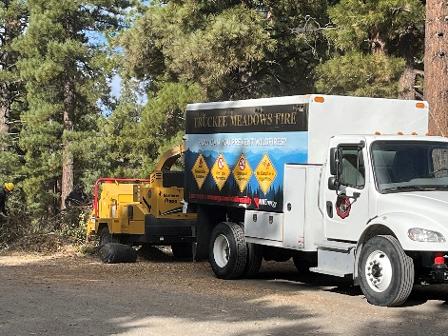[**https://www.livingwithfire.org/fire-adapted-nevada-summit**](https://www.livingwithfire.org/fire-adapted-nevada-summit)

**Fall 2024 Green Waste Collection near Galena Park**

This fall TMFPD sponsored a Green Waste Collection just up the highway near Jones Creek Trail. It was very easy to drop off branches and shrubs in minutes. Then the firefighters chipped the materials for use on trails, etc.

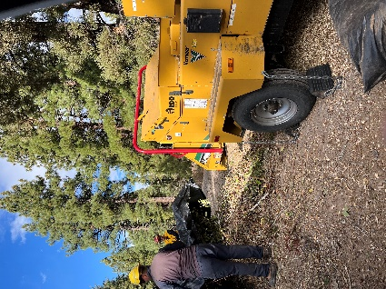**Check out TMFPD Spring 2025 Green Waste schedule in March. Usually, they collect from 8 am- 5 pm. near Washoe Lake and various locations on weekends during the spring.**

Waste Management will pick up six bags per home for 4 weeks in **May**. No stickers required that month for excess waste collection.

**Galena Country Estates has been a Firewise USA for four years**. Homeowners need to do their part in reducing wildfire risks on their property. Read more at our website <http://galenacountryestates.com> under **Fire Protection.** **Because of our membership, we have received free help from TMFPD and NDF clearing ditches and reducing wildland brush on homeowners’ properties.** TMFPD allocated us two free days in 2024 to clear brush away from fences behind properties on Deer Valley Court and Deer Valley Drive. That work is on Monte Rosa property so once TMFPD gets the okay from that HOA, the work will be done in 2025. This work is worth thousands of dollars. If you have an area on your property which needs cleared, please contact Cynthia at [GCE.Firewise@gmail.com](mailto:GCE.Firewise@gmail.com) for 2025 work.

**SAVE the DATE: April 28th, 6 pm. Raley’s Room A**

**Firewise Chat with Brett Taylor, TMFPD**

**Aging Driveways**

Our properties are over thirty years old so mature landscaping and weather are beginning to cause cracks in driveways. Be proactive and fill cracks with cement patch. During winter, water freezing in the cracks causes them to expand. Driveway sealant also helps to keep the water off. Check out your local hardware for products and directions.

Trees that were planted thirty years ago may be too close to the house and driveway. Removing them improves your defensible space against fire and reduces pressure from roots under the cement.

***********************************************

**Volunteers are picking up poop at the Whites Creek Park and trails**. **Responsible dog owners carry bags and, by law, need to pick up their dog’s poop as it is a public health issue. *Thank you for helping!***

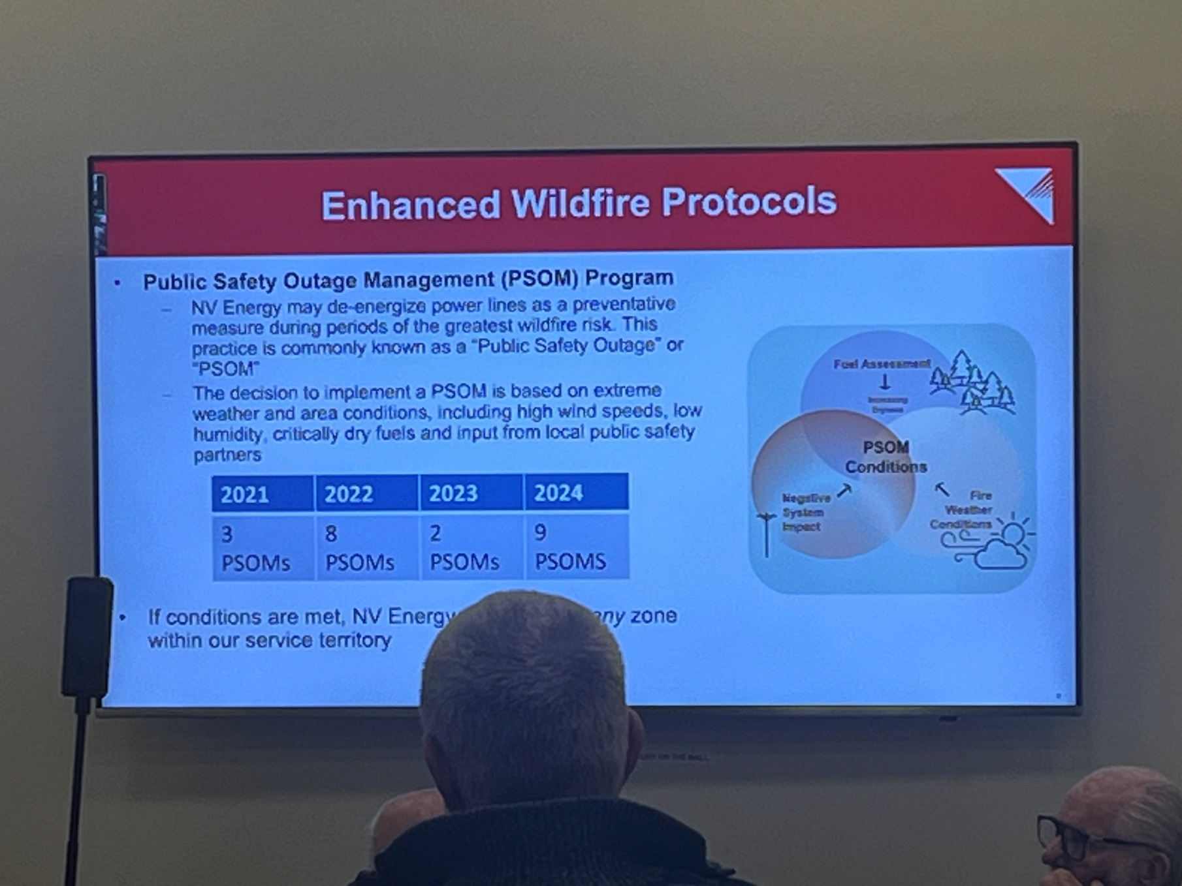 **What does PSOM stand for?**

**Public Safety Outage Management**

When wind guests are predicted to be greater than 40 mph and burning index is greater than 70, NV Energy may de-energize power lines. NV Energy works with emergency teams to make the decision. At the Citizen Advisory Board Meeting on December 5th, 2024, Tim Hill gave an excellent presentation on NV Energy Guidelines. He explained that the issue began after the 2018 Paradise fire, which led to state legislation requiring utilities to implement natural disaster programs aimed at safeguarding communities while maintaining power delivery.

The next South Truckee Meadows/Washoe Valley CAB meeting will be February 6th at the South Valleys Library at 6 pm. Check out agenda. Attend these meetings to be updated on Sheriff and TMFPD reports and other issues in our neighborhood. [STMWV_CAB_Draft_Minutes_December_2024.pdf](https://www.washoecounty.gov/CABS/STMWV_CAB/2025/files/STMWV_CAB_Draft_Minutes_December_2024.pdf)

If you are considering buying a permanent generator, please submit a request to the Architecture Committee (ARC) to make sure the decimals of the unit are low, between 50-70. If the generator is portable, there is no need for ARC approval.

**Holiday Lights & Year-Round Lights**

At our next meeting, March 10th, we will be discussing policy for holiday light removal, probably by February. But if you want to install year-round lights which colors can be changed for different holidays, the Board will be discussing standards and possibly a requirement to get approval through the Architecture Committee. Lights need to be strung tight and neat.

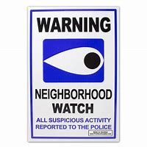**Neighborhood Watch Program** **Survey**

If you would like to learn about the Neighborhood Watch Program with the Sheriff’s Office Community Liaison, **please call Allison at Associa at 775-334-7465 before March 1st to express interest or vote on TownSq survey link.**

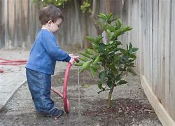**Water those trees when temp is above 40 degrees. It’s been dry.**