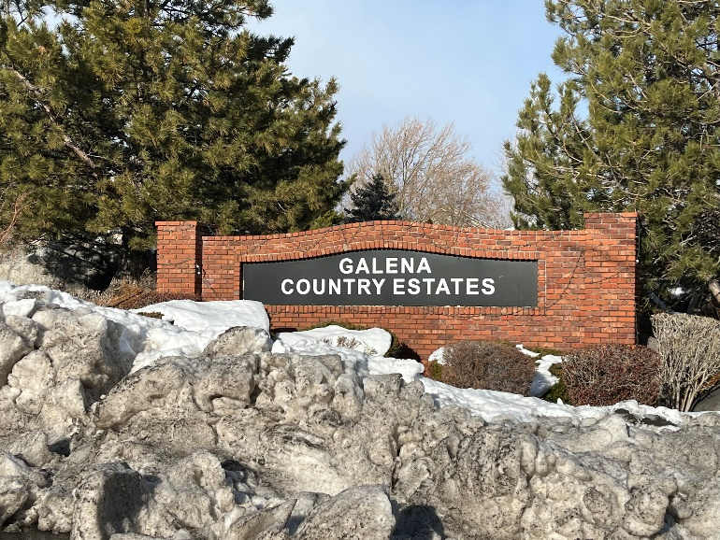**Galena Country Estates**

**Winter News 2023**

Compiled by Cynthia Reed

***Thank you to all the homeowners who made the holiday season cheery with all the decorations! Wasn’t it fun being without power for two days..190 houses! Newcomers should now know why ditches need to be free of debris and maintained so when atmospheric rivers hit, the water can drain to the Truckee River.***

**Mediation Success**

On July 14th, 2022, GCE and Monte Rosa Board Members met via Zoom with Mediator Paul Lamboley who mediated our Nevada Real Estate Division Claim. After paying for 13 years per 2005 agreement, Monte Rosa stopped contributing to the maintenance of Whites Creek Park at the beginning of 2018 with no written explanation to Washoe County or GCE. GCE has being paying for the lawn maintenance costs of Whites Creek Park per county agreement since 1985. In 2005, GCE agreed to pay Washoe County Parks a fixed $11,000 a year to maintain the park grass instead of hiring a landscaping company. So, via mediation, Monte Rosa will payback GCE $3 per house (64 houses) per month from 2018 to present plus pay $3 per house per month moving forward and GCE will continue to pay the balance at $3 per house (249 houses) per month to Washoe County Parks.

**Firewise USA Participant**

**Residents Reducing Wildfire Risks**

As part of our continuing fire education**, Jaime Roice-Gomes,** Living With Fire Manager from the University of Nevada Cooperative Extension, talked about creating Defensible Space to four homeowners and Molly, the cat, on a smoky September 10.th Some of the recommendations are:

* Do not place plants under the eaves of the house.
* Use a pre-emergent to stop weed seeds before they grow (February-March)
* Pull out cheat grass which is very flammable.
* Remove highly-volatile junipers.
* Keep bark away from the base of the house as well as clean out gutters.
* Place 1/8” non-combustible, non-corrosive mesh over vents to keep embers out.

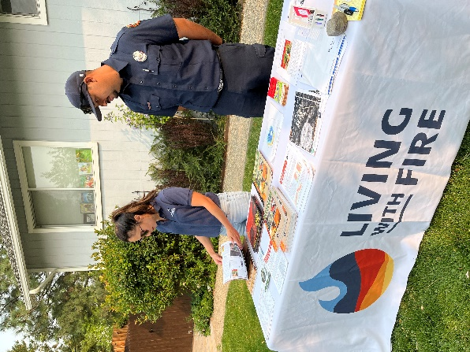**Juan Saldana** from Truckee Meadows Fire PD handed-out a chart showing the most dangerous winds for our area come from the southwest. See chart on next page. Those winds create drafts on the north side of your house which means you need to evaluate your plants on the northside because embers could implode into fires.

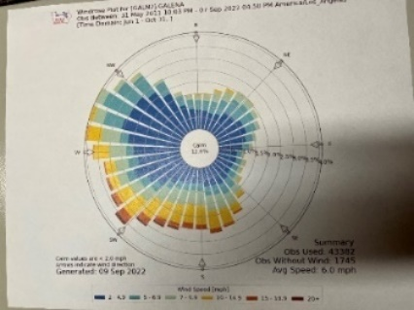You can get a free Defensible Space Evaluation from Juan Saldana, [jsaldana@tmfpd.us](mailto:jsaldana@tmfpd.us) or contact Kelli Nevills, [knevills@forestry.nv.gov](mailto:knevills@forestry.nv.gov). Early spring is a good time before the busy fire season begins.

GCE has been a Firewise USA member for two years. Homeowners in some states are given homeowner insurance discounts if their HOA is a member of Firewise USA. Kelli Nevills is working with the Nevada Division of Insurance to create a way for USAA and other insurance companies to offer their Firewise USA discount to Nevada homeowners as they do in other states.

Check out Fire Protection on the GCE website [www.galenacountryestates.com](http://www.galenacountryestates.com)

Some handouts **are available at the Free Little Library @2425 Solitude Drive**

**or go on-line to Living with Fire** <https://www.livingwithfire.com/> **or Firewise USA.**

**Next FREE educational event is** Feb. 21, 2023, at 6 pm Raley’s Gathering Room A. Learn about **Landscape Weed Management with Jake Dick**, UNR Nevada Dept. Of Agriculture.

**New Management Company**

Starting April 1st, **Associa** will be our new management company. After reviewing bids from our present company, EBMC, and three others, the Board made this change for several reasons. You’ll be receiving information soon.

Consequently, due to increases in legal fees and general cost increases for everything, HOA dues will be increased $4 per month to $24. Homeowners will send $144 to Associa every 6 months starting on **July 1, 2023**.

**Thanks to all those attentive dog owners who pick up after their dog when nobody is watching.**

At the Washoe County Park and Open Space Commission Meeting on Nov. 1, 2022, Commissioners approved the continued shared-use of South Valleys lower soccer field for an off-leash dog area. Until March 1st, the field can be used by dog owners from 8 am-dusk every day. March 1st, the field can be used from 8am-1pm. on weekdays, only. Poop bags are provided and poop stats are recorded to justify this privilege.

If you know any companies or donors who would like to help fund the construction of South Valleys Park Phase 3, which includes a fenced dog park, please contact Denise Evans at Washoe County Parks and she will connect you to the right people: [devans@washoecounty.us](mailto:devans@washoecounty.us) Before Covid, the estimated cost of Phase 3 was $6 million.

Whites Creek Park is NOT an off-leash dog area. Go to [Dog Parks & Off-Leash Areas (washoecounty.gov)](https://www.washoecounty.gov/parks/specialty_facilities/dog_parks.php) If you have any comments on this topic, please e-mail [washoe311@washoecounty.us](mailto:washoe311@washoecounty.us) .

Community Garage Sale, Saturday

May 20th

8 am-1 pm.

It is more efficient to have many homeowners having garage sales on the same Saturday. Signs will be posted at entrances on Telluride and Sundance but please post addresses and goods on Craigslist and/or Nextdoor to help buyers. GCE will be sponsoring ONE community garage sale this year.