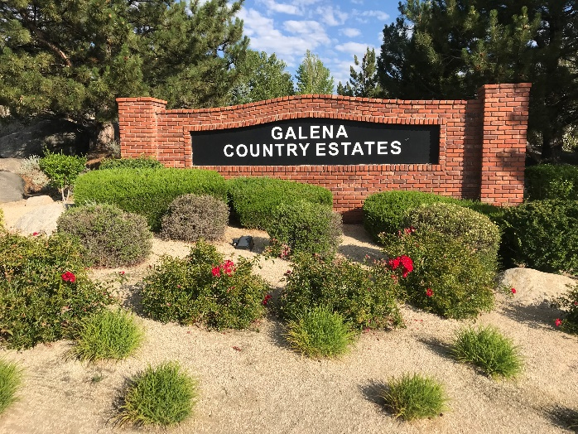

**Galena Country Estates**

**Spring News 2023**

Compiled by Cynthia Reed

**CC&R Petition Approval:** February 7, 2023, our CCR Petition was approved by Judge Connie J. Steinheimez. The GCE Board has attempted for years to get 75% of GCE homeowners to approve or reject the updated CC&R’s that combine several existing documents recorded with Washoe County. Response by 75% is required by our CC&R’s, so without that, the Board petitioned the Court in July for approval. To avoid more litigation on future changes, the Board will need 51% of homeowners to vote. All 249 homes are now under ONE set of rules which you will be receiving.

**Community Garage Sale, Saturday**

May 20th

8 am-1 pm.

It is more efficient to have many homeowners having garage sales on the same Saturday. Signs will be posted at entrances on Telluride and Sundance but please post addresses and goods on Craigslist and/or Nextdoor to help buyers. GCE will be sponsoring ONE community garage sale this year.

**The White’s Creek Playground Improvement Project Completed**

Approved in July of 2021, the playground was upgraded in stages. You may have noticed the older equipment with the metal slide was removed recently and replaced with the pictured equipment. The funding came from Residential Construction Tax in our district costing $66,000.  Whites Creek Park is a public park owned by Washoe County.



**Save the Date**

Saturday September 9th

Potluck

**at Whites Creek Park**

**4:30-7:30**



Bring a chair and your favorite dish. HOA will furnish BBQ TriTip and Chicken plus activities for the kids. If you would like to help with set up and clean up, please

Contact Cynthia Reed, Secretary,

GCE.Firewise@gmail.com

Galena Country Estates has been a Firewise USA for three years. To be a member, our Firewise Coordinators need data on how many hours you’ve spent so far this year on reducing fire risk by raking up leaves, trimming shrubs and trees, eliminating brush, etc. to **GCE.Firewise@gmail.com.** Just estimate hours worked and send cost of renting equipment or hiring professionals to do the work. This membership may help homeowners receive up to 30% off their fire insurance. Check with your insurance agent. Our proof of membership is on our website under Fire Protection.

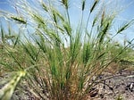**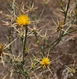On February 21st**, as part of our continuing fire education requirement**, Jake Dick,** fromthe **Nevada Department of Agriculture,** educated us on Noxious Weed Management. Since we’ve had more snow this winter, weeds will be sprouting. **Go to** [**NoxiusWeed@agri.nv.gov**](mailto:NoxiusWeed@agri.nv.gov) **for photo ID** or [**https://agri.nv.gov**](https://agri.nv.gov)toaccess the ***Nevada Noxious Weed Field Guide*** for info including **herbicide recommendations on pg. 127**. Verdi and Mayberry Park have had issues with **Medusahead. Yellow Star Thistle, Goatgrass and Goatheads** are other invasive weeds in our area. **Cheat Grass** can be managed by mowing heads off and spraying pre-emergent by November before seeds start germinating. Buy wildflower seeds from **Granite Seeds or Nevada** **Division of Forestry Nursery** ([885 Eastlake Blvd, Carson City, NV 89704](https://www.bing.com/local?lid=YN873x123469488&id=YN873x123469488&q=Forestry+Division&name=Forestry+Division&cp=39.316566467285156%7e-119.7924575805664&ppois=39.316566467285156_-119.7924575805664_Forestry+Division)) to help prevent invasive weeds from popping up first.

 Truckee Meadow Fire PD Crew Boss, Adam Crichton, suggested signing up on GET Chip Drop ([Free Wood Chips from ChipDrop (getchipdrop.com)](https://getchipdrop.com/) to mulch open areas to control weeds. It is less flammable than store bought mulches.

**Free Defensible Space Evaluation**

You can get a free Defensible Space Evaluation from Juan Saldana, [jsaldana@tmfpd.us](mailto:jsaldana@tmfpd.us) or contact Kelli Nevills, [knevills@forestry.nv.gov](mailto:knevills@forestry.nv.gov). Early spring is a good time before the busy fire season begins.

Check out Fire Protection on the GCE website [www.galenacountryestates.com](http://www.galenacountryestates.com)

Some handouts **are available at the Free Little Library @2425 Solitude Drive**

**or go on-line to Living with Fire** <https://www.livingwithfire.com/> **or Firewise USA.**

**House numbers by Mailboxes Needed**

Firefighters need to find houses quickly and they prefer having house numbers painted in luminous paint under the mailbox. So, our goal this year is to get it done. **HOA will pay for the paint.** E-mail Cynthia Reed, [GCE.Firewise@gmail.com](mailto:GCE.Firewise@gmail.com), if your high schooler or Eagle Scout/Girl Scout/4Her or family could help our community.

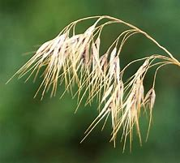

**New Management Company**

Starting April 1st, **Associa** will be our new management company. After reviewing bids from our present company, EBMC, and three others, the Board made this change for several reasons. You’ll be receiving information soon.

Consequently, due to increases in legal fees and general cost increases for everything, HOA dues will be increased $4 per month to $24. Homeowners will send $144 to Associa every 6 months starting on **July 1, 2023**.

Dog poop has been a big problem in all parks, especially with the snow. Help out by picking up extra. **Responsible dog owners carry bags and, by law, need to pick up their dog’s poop as it is a public health issue.**