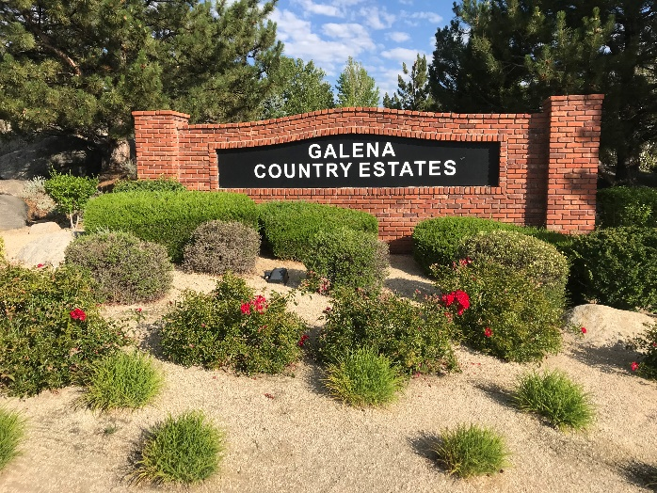 **Galena Country Estates**

**Fall News 2024**

Compiled by Cynthia Reed

**Fall Community Clean-up**

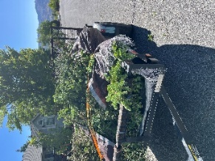Keep those yards clean and lean for fire safety plus general yard maintenance. Homeowners have three ways to dispose of green waste:

First, Truckee Meadows Fire PD (TMFPD) will hold Green Waste Collection this fall, probably in **October**. Check **tmfpd.us** for dates and details. **The firefighters remove all the brush from your trailer or truck. Fast and easy! The Washoe Valley site at Nevada Division of Forestry Fire Station, 885 Eastlake Blvd, is the closest for us. If you do not have a way to transport your trimmings, please contact Cynthia Reed, your Firewise Coordinator, (GCE.Firewise@gmail.com). She has a 12’ trailer and will help you load it & take to the collection area.**

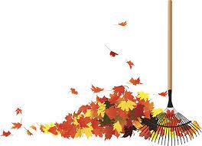 Second, **Waste Management**, for four weeks in **November**, will pick up to 6 extra bags/trash cans (leaves, limbs, pine needles & other trash) with **NO** yellow/orange stickers (free) during regular trash pickup.

Finally, homeowners in Washoe County have **four free** dumps a year at the transfer station off Sutro. Just bring a bill with account no. and ID. Three cubic yards per load.



**Please pull back trash/recycling cans within 24 hours of pickup. Help a neighbor!**

**Big thanks to homeowners who pull those weeds out and rake up those leaves plus clean house and street gutters so drainage isn’t blocked during rain storms! Please cut-off limbs on the lower third of your pine trees. It is a defensible space strategy.**

**Homeowners with ditches/easement roads are responsible to clear out brush & weeds, too.**

**Survey Results for Fall Picnic**

**Associa**, our management company, sent out a survey via Town Square to see if residents would participate in a potluck picnic at Whites Creek Park. **Only 12 residents** responded so we will **NOT** be organizing that event. This was a quick way to get everyone’s opinion. If you’d like to participate in future surveys,

**please register for Town Square (www.townsq.io)** via a phone app or computerto improve communications and save “snail mail” costs (stamp + labor= added Associa fees)**.**  **Use your e-mail and your Associa Account # to register.** View your account, announcements, find documents, contact Associa, and more!

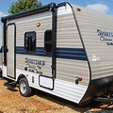**Visitors parked in driveway with RV or trailer?** Please e-mail Paige, our Associa Manager, [PBoesen@Associasn.com](mailto:PBoesen@Associasn.com) or call the office at 775-626-7333 to leave a message with length of time.

**Want the bears to hibernate? Last winter the bears were still around in December because they could find fruit and garbage to eat in our neighborhood. Please pick the fruit from your trees and consider contacting Gleem or other food pantries to distribute if edible. Otherwise, pick the fruit off the ground and trees to keep bears away. Consider getting bear proof trash cans or ordering special locks you can install.**

**Fire Hydrant Reminder:**

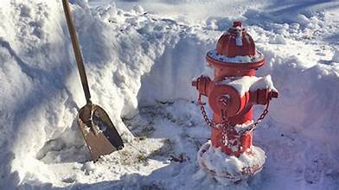Fire Hydrants are marked again with a reflective orange pole. All 22 fire hydrants in the neighborhood need to be maintained by homeowners. That means bushes and limbs need to be cut away from the hydrant so it can be seen. Snow needs to be removed from around the hydrant so firefighters can access it.

**Firewise USA Participant**

Galena Country Estates HOA has been a member of Firewise USA since 2021. Our Firewise Coordinator Team attended the first Fire Adapted Nevada Conference at UNR last spring to connect with other homeowners plus county, state, and federal agencies.

Because of those connections, we were able to get additional help thinning out wildland brush. Last fall, the Nevada Division of Forestry (NDF) saved our homeowners thousands of dollars by cleaning four major ditches in our subdivision using federal grant money. Now it is up to those homeowners to control growth of weeds by whacking out the weeds each spring and fall. Homeowners can also use herbicides (kills weeds) and/or pre-emergent (to kill seeds only) at least 3 times a year. Contact Shaun Gephart, NDF Herbicide Specialist, [sgephart@forestry.nv.gov](mailto:sgephart@forestry.nv.gov) for advice.

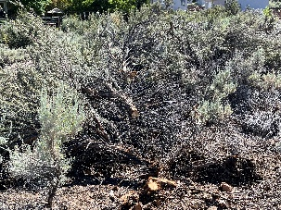**Truckee Meadows Fire PD** (TMFPD) is now offering all Firewise communities two FREE squad days per year as a thank you for maintaining our Firewise status. So, please take the time to become more knowledge about defensible-space strategy and report what you do to our Firewise Team by simply e-mailing [GCE.Firewise@gmail.com](mailto:GCE.Firewise@gmail.com) the hours you spend or paid for equipment or help.

**If you have an easement or ditch area covered with sage or other brush which is a fire hazard, please let the Firewise Team know so you could benefit from the TMFPD offer. They can also chip branches. Other ideas? The Board will be discussing what GCE areas need TMFPD’s specialized labor and equipment for wildfire mitigation at Oct. 21st HOA meeting.**

**Tips For Fire Safety Next to your House:**

**(Non-combustible Zone 0)**

* **Keep the first five feet away from your home free of combustible materials.**
* **Remove tree branches within 10 feet of the home.**
* **Use hardscaping materials such as rock, concrete, bricks or pavers.**
* **Place 1/8” stainless steel mesh over vents to prevent embers from entering attic or crawl space.**
* **Clean out pine needles and other dead vegetation out of gutters and all around the house. Costco has stainless steel gutter guards.**

**Additional resources under Fire Protection atgalenacountryestates.com.**

***Embers are the big threat.***

Handouts **are available at the Free Little Library @2425 Solitude Drive**

**or go on-line to Living with Fire** <https://www.livingwithfire.com/> **or Firewise USA.**