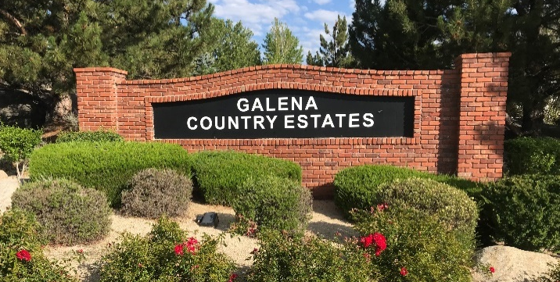
Welcome to Galena Country Estates HOA -249 Homes
You are living within a homeowner’s association which has basic rules that each renter/homeowner needs to be aware of by reading the CC&Rs on our website at www.galenacountryestates.com. But below are a few helpful tips:
- Garbage pickup is on every Tuesday. Recycle (blue lid) pickup is every other Tuesday. Check Waste Management for schedule. If your trash can is full, you can set out excess waste in trash bags/cans and label with a yellow sticker sent to homeowners every December. If you are a renter, ask your landlord for those stickers. During the months of May and November, you can sit out up to 6 bags for free (no sticker needed).
  - Black bears have discovered our area a few years ago. Fruit trees and garage cans have attracted them so it is important to keep trash cans in your garage or get a bear resistant trash can from WM. For more information, go to Living With Bears - Nevada Wildlife (ndow.org)

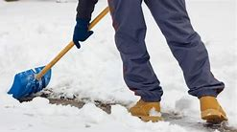
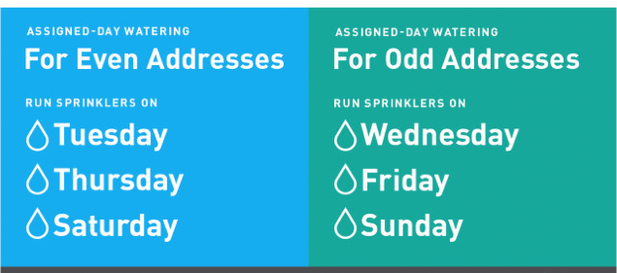
- Yard Maintenance: Front yards need to be free of weeds; trees and bushes need to be pruned and grass/rock maintained. Truckee Meadows Water Authority promotes smart water use to conserve this valuable resource. Running your sprinklers three days a week under the assigned-day watering schedule keeps your yard healthy and your water bill low while avoiding waste. Prevent clogging of street drains by removing leaves along the curbs. Snow removal off sidewalks and around fire hydrants on your property is the homeowner’s or renter’s responsibility.

- Boats, travel trailers, tent trailers, multi-use trailers, motorhomes, and trucks with campers need to be parked behind a six-foot solid fence unless loading or unloading.
- Whites Creek Park is a public park owned by Washoe County but our HOA, as per 1985 agreement, helps pay for the lawn maintenance. So, pick up trash and dog poop anywhere in the neighborhood and on trails.
Our management company is Associa Sierra North.
You can contact our manager, Paige Boesen, PBoesen@Associasn.com or 775-626-7333 Your volunteer HOA Board Members

