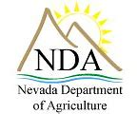
You’re Invited
Noxious Weed Management Talk
from a landscape perspective

Tuesday, February 21st,2023, 6 p.m.
Gathering Room A by deli, at Raley’s on Wedge

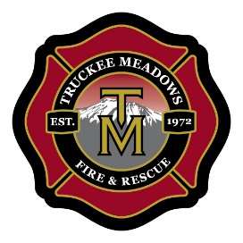
Join us for an in-person Noxious Weed Management Presentation by Jake Dick, Noxious Weed Coordinator, Nevada Department of Agriculture. Find out how to treat the weeds. Also, Kelli Nevills, State Firewise USA Coordinator, Nevada Department of Forestry will be available to answer questions from a fire risk perspective.
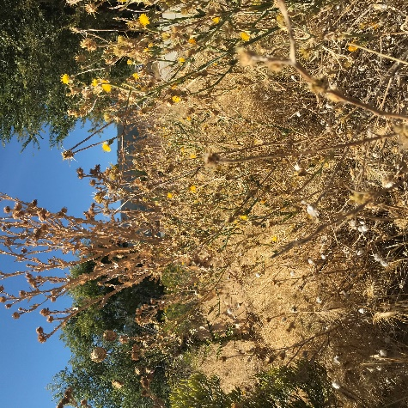
Handouts
Information—
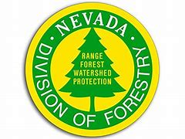
What is a weed?
Is sagebrush a weed?
Is cheat grass a weed?
How do we manage weeds?

Galena Country Estates HOA is a member of Firewise USA. Our 2023 goals are to become more educated on how to reduce wildfire risks in our subdivision and the Mt. Rose Corridor. Presentation sponsored by your GCE Firewise USA Committee.
Contact us: GCE.Firewise@gmail.com

